Implementation Of Textile Antenna With SAR Measurements For Wearable Communication

In Medical Applications

Sreedevi. B Assistant Professor, Department of ECE, St. Joseph’s Institute of
Technology, Chennai, Tamil Nadu, India
600119,
sreedevistjoseph@gmail.com
Saranya.U Student, Department of ECE,
St. Joseph’s Institute of Technology,
Chennai, Tamil Nadu, India 600119,
sarannx2004@gmail.com
Yamini.S
Student, Department of ECE, St. Joseph’s Institute of
Technology, Chennai, Tamil Nadu, India
600119,
yaminisuresh07@gmail.com

Mohan. C Assistant Professor, Department of ECE, St. Joseph’s Institute of
Technology, Chennai, Tamil Nadu, India
600119,
mohanrc803@gmail.com

Abstract— This paper introduces a new multi band meander patch antenna designed for optimal performance in medical applications. The antenna structure is in meander shape to achieve multi band functionality as well as low frequency as it is used close to the human skin in order to monitor the brain function. The proposed antenna has compact dimensions of 48 x 58 x 2 mm³. For multi band function, the antenna operates in various frequency bands, enabling us to have various application but we choose 2.2 GHZ for better functionality. This antenna is multi band, has more applications, it is compact, and it has low SAR (Specific Absorption Rate), the low the SAR values the less the health risk as it is the amount of radio frequency absorbed by human body.
Keyword – Multi-band, Meander shaped, SAR .

INTRODUCTION

SAR (Specific Absorption Rate) SAR measurement is an important step to guarantee the safety of the antenna for wearable use. SAR values are tested by using standardized phantoms that represent human tissue, along with specific equipment. Measurements are taken at various operating frequencies to assess the electromagnetic energy absorption level in the body. This ensures that safety standards are met according [1]. The accepted SAR value is 1.6 W/KG, and this is achieved by design and optimized antenna system with slots. If the SAR values exceed tolerable limits, modifications are done in the design to reduce energy absorption. The iterative process of measuring and adjusting ensures that the antenna remains safe for the user and is performed with high performance and efficiency [2].
Recent times the new development is the multi band antenna as this antenna can work in various frequencies, we can have various applications. This is cost effective rather than earlier versions of antenna [3]. A compact patch antenna has been developed for biomedical applications.

Slots are incorporated into this design to reduce SAR and improve performance when attached on [4] the human body.
Textile antennas are used in wearable technologies as they are flexible light-weight and conductive fibers that normal antenna cannot provide as they are rigid [5]. Textile antennas are designed on flexible substrate here we use cotton. The height of substrate used here is 2 mm [6]. Here it is designed on cotton substrate in order to detect aneurysm that is weakening of blood vessels in brain [7].
This design is multi-band providing various frequencies thus many applications and this is achieved by an antenna structure which has a meander shaped patch [8] of dimension 48 x 58 x 2 mm³.This antenna radiates at multi band and it resonates at 2.2 GHZ. Antenna design also involves low SAR values thus it can be used in wearable applications as it reduces radiation exposure to human body [9]. Cotton has been used in this antenna in order to support wearable technologies. This enhances the flexibility, adaptability, functionality and performance of antennas [10]. This flexible multi-band antenna has crucial role in medical application here it is used detecting the performance of brain. The blood flow through the weakened blood vessels in the brain is sent through this multi-band flexible antenna [11].

DESIGN AND ANALYSIS
The detailed analysis of this designed antenna is given below. The proposed design is given in figure 1.
Rectangular patch is created as starting shape and then it is slotted in zig-zag pattern produce meander shape. This structure produces less SAR values to minimize radiation effects [12]. This design uses flexible substrate like cotton with height 2
mm. Ground used here is made up of cotton with thickness
0.035 mm. The width and length of substrate are 48 and 58
mm. And the width and length of ground are given as 48 And 58 mm. The length and width of the rectangular patch are given as 35 and 40 mm. Later this rectangular patch is slotted in zig zag pattern to produce meander shape.

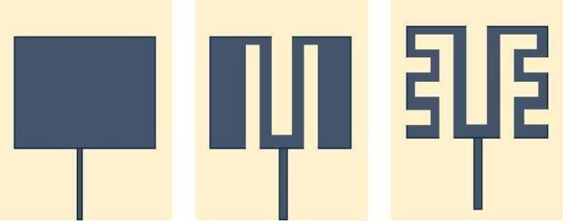


Figure 1. Detailed view of the proposed antenna.
For signal to be transmitted from source to the antenna we use a medium called feed line [13].
The length and width of feed line are given as 11.5 and 1
mm. Meander pattern is formed by providing 7 slots with various dimensions. First slot S1 with length 38 mm and width 8 mm followed by second slot S2 with length 38 mm and width 4 mm then comes third slot S3 which is identical to S2 on left side. Fourth slot S4 with length 4 mm and width 8 mm. Fifth, sixth and seven slots have same dimension of length 4 mm and width 8 mm on either side of S1. The slots are given in the figure 2.
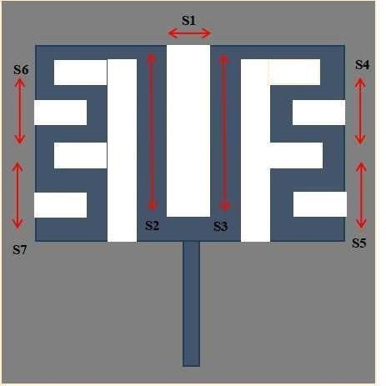

Figure 2. Slots of the proposed antenna.
The development of this antenna involves several stages, as shown in figure 3. Figure 3 depicts the stages involved in designing the front side of the antenna, specifically the structure of the patch with slots

The front view of the Antenna design is shown in the figure 3 below.
(a) (b) (c) Figure 3 Front view
Figure 3(a) is basic rectangular patch placed on cotton substrate with width and length of rectangular patch is 48 and 58 mm. Then slots are added to this patch in order to meet our requirements. In Figure 3(b) The rectangular patch is further. Detailed by adding slots. Slotting is done to achieve the desired output of 2.2 GHz. At this stage, the patch is slotted in a rectangular shape with a length of 28 mm and a width of 8
mm. This slotting process is repeated three times. In Figure 3(c) the design is modified to produce low frequency by adding few more identical slots of length 4 mm and width 8
mm. These slots on the patch forms a meander shape.

TABLE 1. PARAMETERS OF THE PROPOSED ANTENNA

Parameter | Size (mm) | Parameter | Size (mm)
WS | 48 | LS | 58
WF | 1 | LF | 11.5
WP | 40 | LP | 35

- RESULTS AND DISCUSSION
The antenna is designed and return loss is also provided in figure 4. This is designed is CST software version 2024.The surface current, H- field and E-field is monitored and provided in figure 5,6 and 7.E- field is electric component and H-field is magnetic component of waves. Surface current denotes the current present in conductive layer of the antenna. These provide us information on region in the antenna where current flow is more or less [13]. These functionality helps in knowing about the overall performance and ability of the antenna. Thus, these are monitored and checked for desired output. As a multiband flexible antenna, it can work under 2.2 GHz as well as 6.6 GHz. But here we focus on 2.2 GHz frequency as it is used in medical application moreover, we implement this antenna design in the cap made of cotton as it is wearable and can satisfy our need of detecting brain functionality. Resulting in the overall dimension of this multi- band flexible antenna is 48 x 58 x 2
mm. This antenna has less return loss at 2.2GHz with value of -38 dB.
The frequency and its return loss are shown in Figure 4. As this is a multi-band flexible antenna, it operates at various frequencies and serves different applications. Our focus is on the frequency at 2.2 GHz

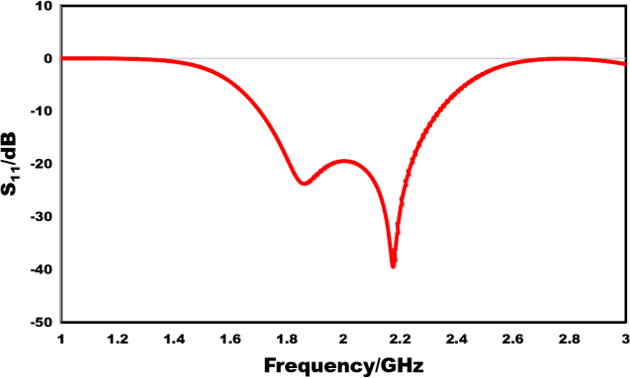
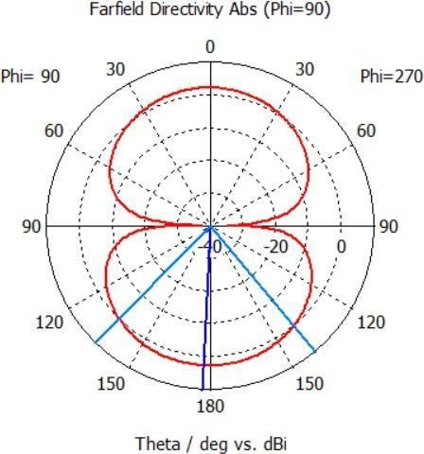
Figure 4.
Return loss of the proposed antenna

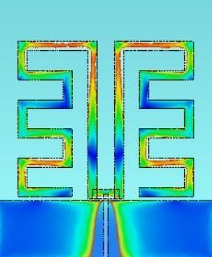
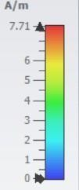
The figure depicts the return loss value of the proposed antenna at frequency (2.2 GHz) and it is denoted as S11. The return loss value at 2.2GHz is -38 dB

Figure 5. Surface current of the proposed antenna.

From this figure, we observe that more current flows near the slots S1, S2, and S3. This behavior makes the antenna multiband, enabling it to support multiple applications. This is the surface current of the proposed antenna at 2.2 GHz.
The figure 6 depicts the E-field of the proposed antenna and figure 7 depicts the H-field of the proposed antenna. As stated, it is the electric and magnetic component of electromagnetic waves. The following figures are the E- field and H-field of the flexible antenna at 2.2 GHZ
The E-Field pattern result is shown in the figure given below.

Figure 6 E-field pattern of the proposed antenna
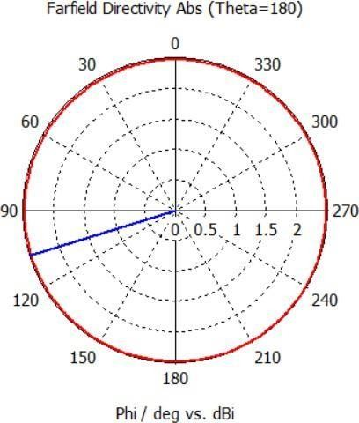
Figure 7.H-field of the proposed antenna.
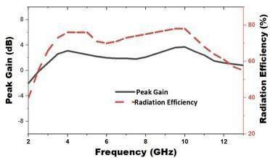
Figure 8 depicts the frequency and the peak gain plot Through which we can analysis the peak gain based on the frequency. This provides the relationship between Frequency and peak gain and their dependency. The Peak gain is given for the frequency at 2.2 GHz and 6.6 GHz.

Figure
8. Peak gain and frequency analysis.

CONCLUSION
A multi-band cotton flexible antenna with a meander shaped patch made with 7 slot is shown in this study. The suggested antenna, which has gains of -38 dB at 2.2 GHz. This antenna has cotton substrate so it is flexible and used in wearable technologies. The height of substrate is 2mm. The design in meander shape with cotton substrate and copper patch has dimension of 48 x 58 x 2 mm³. This has a lower SAR value and reduced return loss, which can maximize its efficiency in medical applications.

REFERENCES

- Ali U, Ullah S, Khan J, Shafi M, Kamal B, Basir A, Flint JA, Seager RD. Design and SAR Analysis of Wearable Antenna on Various Parts of Human Body Using Conventional and Artificial Ground Planes. Journal of Electrical Engineering & Technology. 2017;12(1):317-328.
- Garg R, Bhartia P, Bahl I, Ittipiboon A. Microstrip Antenna Design Handbook. Norwood, MA: Artech House, 2001.A.
K. Gupta, P. Sharma, and R. P. Singh, "A novel compact multi-band antenna for wireless communication systems," Proceedingsof the 2019 IEEE International Conference on Communications and Signal Processing, Chennai,India, pp. 675-678, Dec. 2019.
- Xiao et al.Mult-iband and Low-Specific-Absorption-Rate Wearable Antennawith Low Profile Based on Highly Conductive Graphene Assembled Film. IEEE Antennas and Wireless Propagation Lettersvol. 22, no. 9, pp. 2195-2199,
Sept. 2023.
- R. Salvado, C. Loss, R. Gonçalves, and P. Pinho, "Textile Materials for the Design of Wearable Antennas: A Survey," in Sensors, vol. 12, no. 11,pp. 15841-15857, 2012.
- R. Sharma, P. Verma, and S. Gupta, "Development of Textile Antennas on Flexible Cotton Substrates for Wearable Applications," in International Journal of Antenna Research, vol. 9, no. 3, pp. 112-120, 2022.
- A. Kumar, S. Patel, and R. Singh, "Design of Textile Antennas on Cotton Substrates for Aneurysm Detection in Cerebral Applications," in Biomedical Signal Processing and Control, vol. 73, pp. 103423-103430, 2023.
- M.Patel, S. Kaur, and V. Singh, "Multiband Textile Antenna Design with Meander Shaped Patch for Diverse Applications," in Journal of Microwave and Antenna Design, vol. 14, no. 2, pp. 87- 95, 2023.
- S. Patel, M. Kumar, and L. Singh, "Low SAR Design of Textile Antennas for Wearable Applications: Minimizing Radiation Exposure," in Journal of Electromagnetic Engineering and Applications, vol. 10, no. 4, pp. 135-142,
2023.
- A. Kumar, R. Sharma, and P. Gupta, "Textile-Based Antenna Design for Wearable Technology Applications," in Journal of Wireless Communication and Antenna Design, vol. 18, no. 3, pp. 45-53, 2023.
- A. Khan, R. Mehta, and T. Roy, "Flexible Multiband Antennas for Brain Monitoring: Applications in Medical Diagnostics," in IEEE Transactions on Antennas and Propagation, vol. 71, no. 2, pp. 234-242, 2023.
- Raj, M. Verma, and K. Singh, "Design of Meandered Rectangular Patch Antennas with Low SAR for Wearable Applications," in Progress in Electromagnetics Research, vol. 82, no. 4, pp. 128- 137, 2023.
- A. K. Gautam, S. Yadav, and B. K. Kanaujia, "Design and Analysis of Surface Current Distribution for Circular Patch Antenna with and without Slot," in AIP Conference Proceedings, vol. 3161, no. 1, pp. 020221, 2023.

